|  |
| --- |
| Albert’s inc. games |
| Burning Tires |
| When The Rubber Meets The Road! |
| Version 1.0  All work Copyright © 2012 by Albert’s Inc. Games.  All rights reserved. |
| **Albert Monteiro**  **Anant Prajapati**  **Aakash Oza** |
|  |

|  |
| --- |
| Apr 11, 2016 |

**Table of Contents**

[Version History…………………………………………………………………………………………………………………………](#VersionHistory)4

[Game Overview…………………………………………………………………………………………………………………………](file:///C:\Users\Albert\Desktop\Semester%206\COMP%20305%20-%20Game%20Programming%201\External%20Game%20Document%20-%20Template.docx#GameOverview)5

[Game Play Mechanics……………………………………………………………………………………………………………….5](#GamePlayMechanics)

[Camera……………..………………………………………………………………………………………………………………………5](#Controls)

[Controls…………………………………………………………………………………………………………………….………………5](#Controls)

[Saving and Loading……………………………………………………………………………………………………………………5](#Controls)

[Interface Sketch………………………………………………………………………………………………………………………..5](#InterfaceSketch)

[Menu and Screen Description…………………………………………………………………………………………………..6](#MenuAndScreenDescription)

[Game World…………………………………………………………………………………………………………………………….11](#GameWorld)

[Levels……………………………………………………………………………………………………………………………………….11](#Levels)

[Game Progression…………………………………………………………………………….……………………………………11](#GameProgression)

[Characters……………………………………………………………………………………………………………………………….12](#Characters)

[Non-player Characters…………………………………………………………………………………………………………….12](#NonPlayerCharacters)

[Enemies…………………………………………………………………………………………………………………………………12](#Enemies)

[Weapons…………………………………………………………………………………………………………………………………12](#Weapons)

[Items…………………………………………………………………………………………………………………………….…………12](#Items)

[Abilities…………………………………………………………………………………….……………………………………………12](#Abilities)

[Vehicles……………………………………………………………………………………….…………………………………………](#Vehicles)12

[Script……….………………………………………………………………………………….………………………………………](#Script)….12

[Scoring…….………………………………………………………………………………….………………………………………](#Scoring)….12

[Puzzles/Mini-games………………………………………………………………………………….…………………………](#PuzzlesMiniGames)….13

[Bonuses…..………………………………………………………………………………….…………………………………………](#Bonuses)13

[Cheat Codes……………….……………………………………………………………….…………………………………………](#CheatCodes)13

[Sound Index…………………………………………………………..……………………………………………………………….13](#SoundIndex)

[Story Index………………………………………………………………………………………………………………………………13](#StoryIndex)

[Art/Multimedia Index…………………………………………….…………………….…………………………………………](#ArtMultimediaIndex)14

[Design Notes……………………………………………………………….………………….………………………………………](#DesignNotes)15

[Future Features………………………………………………………………………………………………………………………](#FutureFeatures)15

[Links………………………………………………………………………………………………….………….…………………………16](#Links)

**Version History**

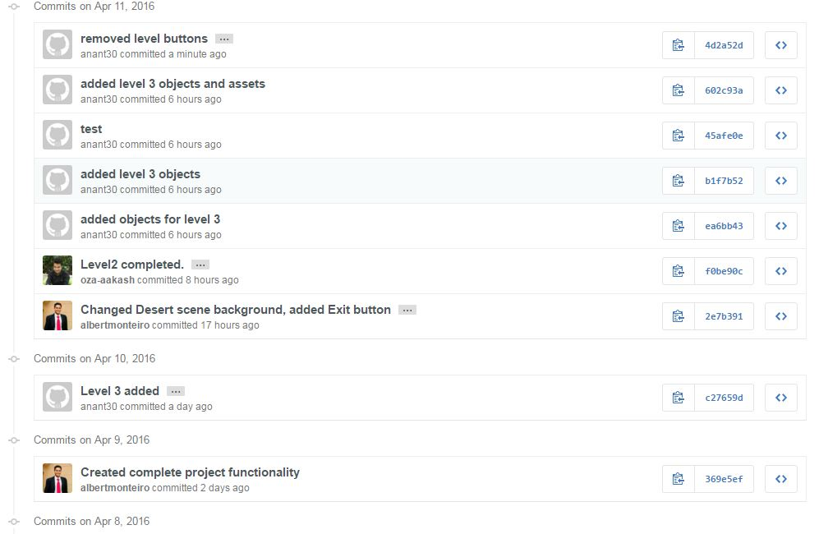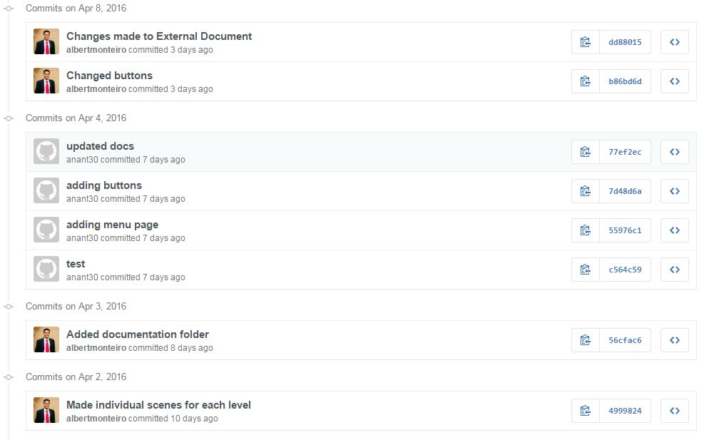

1. **Game Overview**

*Wanna beat the heat!! Welcome to burning tyre where rubber test is strength against the road. The game consists of three different levels with all three different scenarios. The aim of player should be to collect as many as points possible to move to the next level. Player has 5 lives which can spare him from collisions. The game gets over as soon as lives get to zero. The score increases as you keep on collecting the desired objects.*

1. **Game Play Mechanics**

**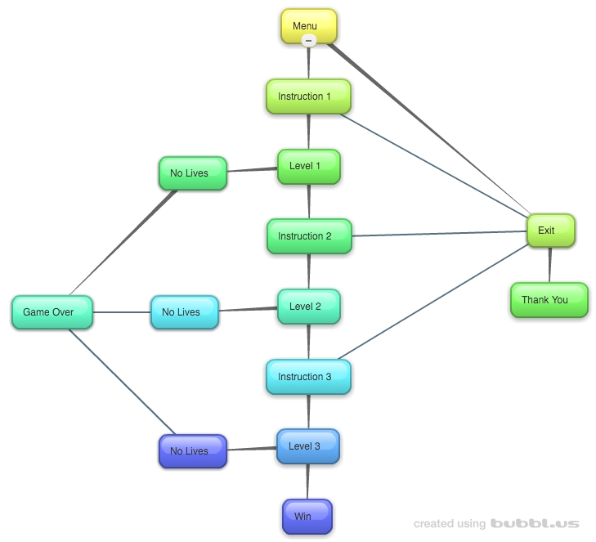**

*There are 3 different levels. On winning each and every level the difficulty level increases and you move to the higher level. The times starts beating as soon as the game start and you win if you survive till the time gets over. As soon as lives get over you exit the game as your games get over.*

1. **Camera**

*No camera is available.*

1. **Controls**

*Player can control with mouse.*

1. **Saving and Loading**

*The game does not have save and load function.*

1. **Interface Sketch**

**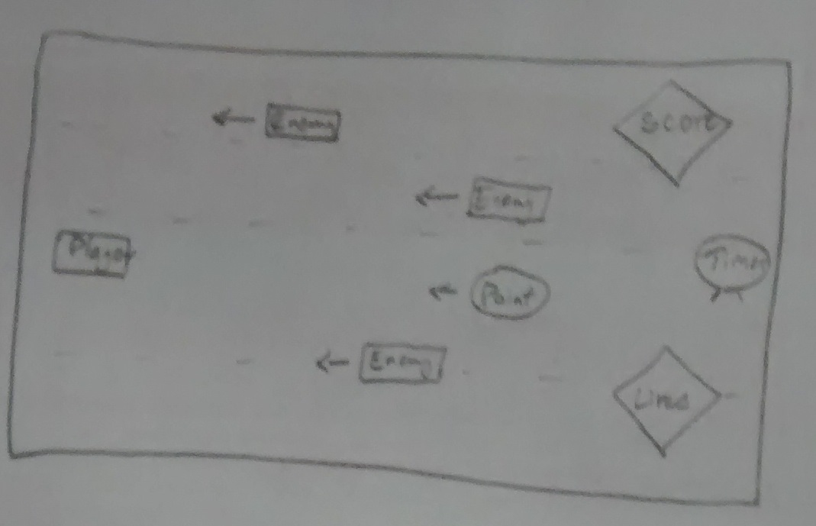**

**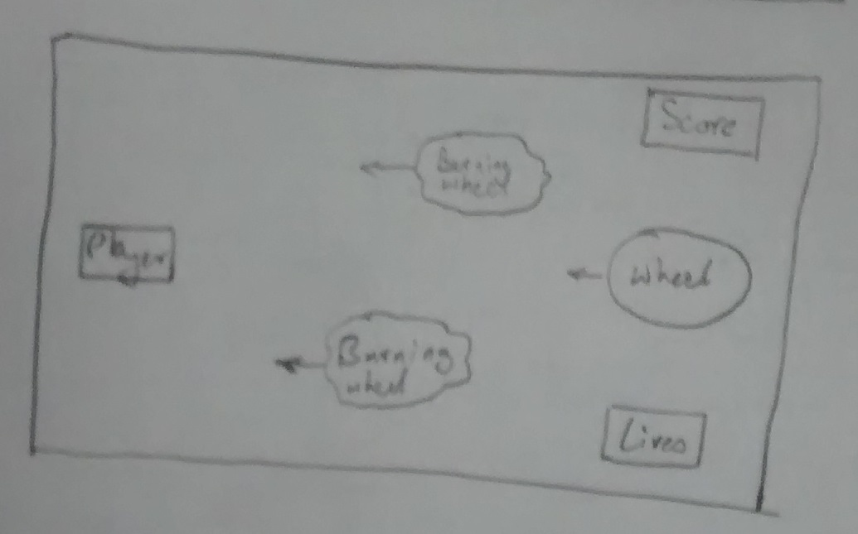**

**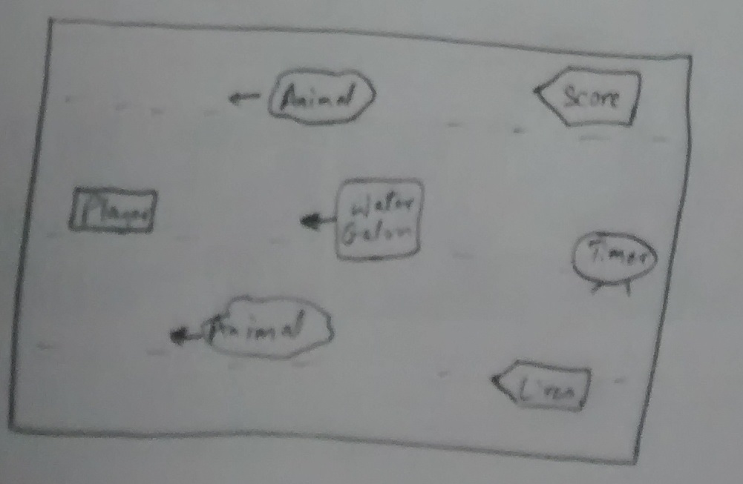**

1. **Menu and Screen Descriptions**

Menu page has a PLAY button to play the game, also includes Instructions button.

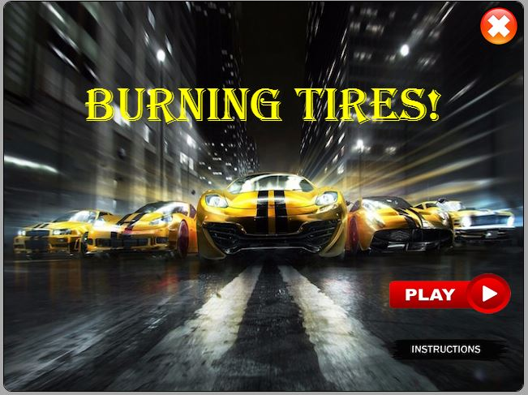

**Menu Screen**

The instruction screen gives user idea how the game should be played. It also has a back button to go back to the main screen so that he can play the game or a close button is also provided to exit the game.

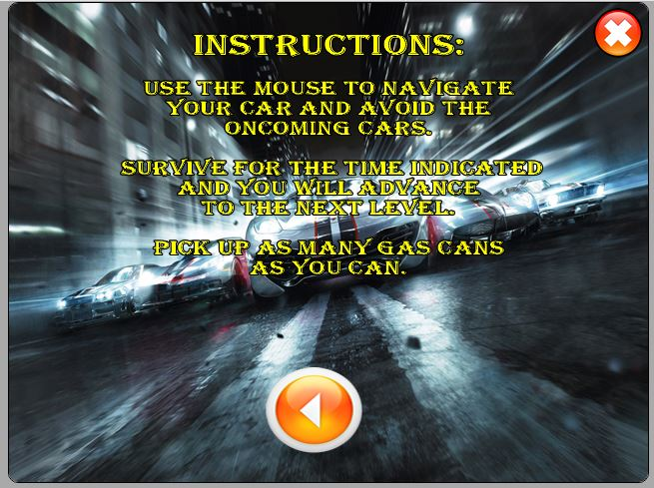

**Instruction Screen**

*Level 1 scene. Save yourself from incoming cars and collect gas to increase your score.*

*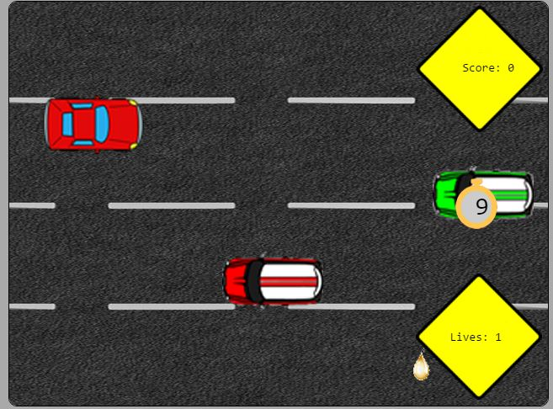*

**Level 1**

*Level 2 scene. Save yourself from incoming burning wheels and also collect the normal wheel to increase your score. Player can also see their lives and score.*

*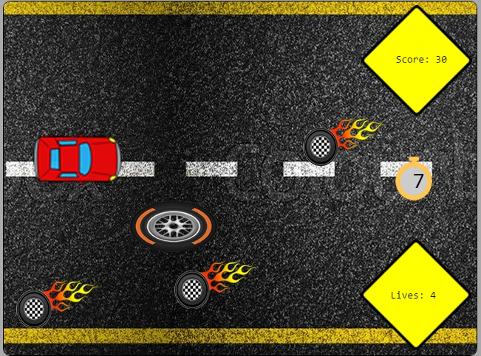*

**Level 2**

*Gameover scene tells player their finalscore and did the beat the highest score or not.*

**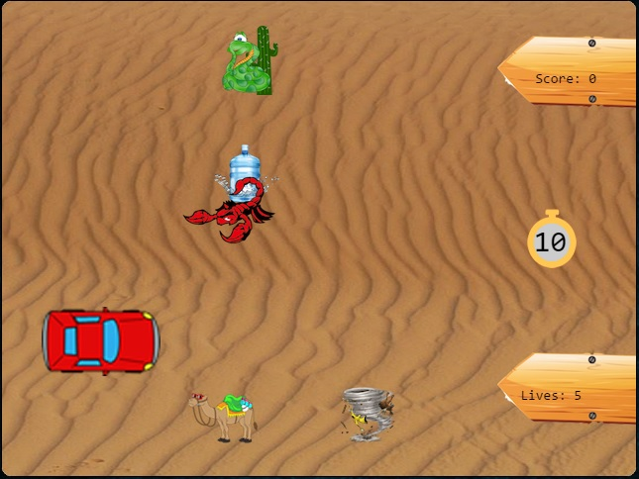**

**Level 3**

*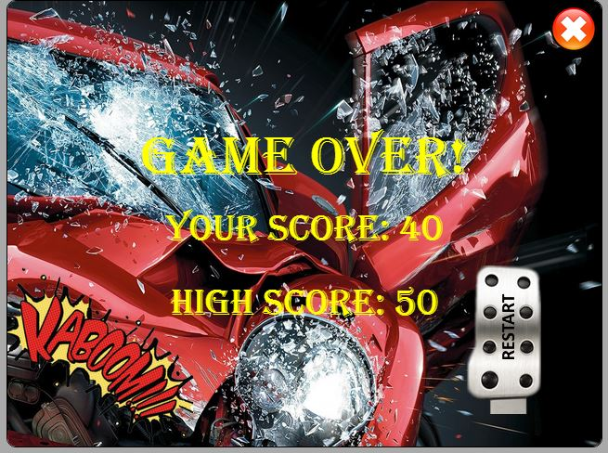*

**Game Over Screen**



**Winning Screen**

1. **Game World**

*As the level increase the environment becomes intense. Level 1 display the systematic lane driving where every car drive sin its own path where as in level 2 there is not systematic path and enemies comes more fast the previous level.*

1. **Levels**

Level 1

Level 2

Level 3

1. **Game Progression**

*The game progress as you keep yourself safe till the times ends. The more you progress the more difficult game gets.*

1. **Characters**

*Player character is the car.*

1. **Non-player Characters**

Cars, burning wheel and wheels are controlled by the computer.

1. **Enemies**

*The enemies in these games for two levels are cars and burning wheels.*

1. **Weapons**

*No weapons in this game.*

1. **Items**

*Gas and normal wheel on collecting increases your score in game.*

1. **Abilities**

**N/A**

1. **Vehicles**

*Cars are the vehicles for this game.*

1. **Script**

**N/A**

1. **Scoring**

*On collecting gas and normal wheel the score gets on increase.*

1. **Puzzles/Mini-games**

**N/A**

1. **Bonuses**

**N/A**

1. **Cheat Codes**

**N/A**

1. **Sound Index**

*Car crash sound*

*Car rev sound*

*Car start sound*

*Gameover sound*

*Gastank sound*

*Level1background music*

1. **Story Index**

*Welcome to burning tyre where rubber test is strength against the road. The game consists of three different levels with all three different scenarios. The aim of player should be to collect as many as points possible to move to the next level. Player has 5 lives which can spare him from collisions. The game gets over as soon as lives get to zero. The score increases as you keep on collecting the desired objects.*

1. **Art / Multimedia Index**

|  |  |  |
| --- | --- | --- |
| **Name** | **Image Preview** | **Source** |
| Backbutton | C:\Users\Aakash\Desktop\COMP397-bob\Assets\images\BackButton.png | Asset |
| Blue\_car | C:\Users\Aakash\Desktop\COMP397-bob\Assets\images\blue_car.png | Asset |
| Burning wheel | C:\Users\Aakash\Desktop\COMP397-bob\Assets\images\burningWheel.png | Asset |
| End scene background | C:\Users\Aakash\Desktop\COMP397-bob\Assets\images\endSceneBackground.png | Asset |
| Exit button | C:\Users\Aakash\Desktop\COMP397-bob\Assets\images\exitButton.png | Asset |
| Game over | C:\Users\Aakash\Desktop\COMP397-bob\Assets\images\gameover.png | Asset |
| Gas can | C:\Users\Aakash\Desktop\COMP397-bob\Assets\images\gas_can.png | Asset |
| Green car | C:\Users\Aakash\Desktop\COMP397-bob\Assets\images\green_car.png | Asset |
| Instruction1 background | C:\Users\Aakash\Desktop\COMP397-bob\Assets\images\instruction1Background.png | Asset |
| Instruction button | C:\Users\Aakash\Desktop\COMP397-bob\Assets\images\InstructionButton.png | Asset |
| Level1 live box | C:\Users\Aakash\Desktop\COMP397-bob\Assets\images\level1LivesBox.png | Asset |
| Level 1score box | C:\Users\Aakash\Desktop\COMP397-bob\Assets\images\level1ScoreBox.png | Asset |
| Level1 timer box | C:\Users\Aakash\Desktop\COMP397-bob\Assets\images\level1TImerBox.png | Asset |
| Level 2 road | C:\Users\Aakash\Desktop\COMP397-bob\Assets\images\level2Road.png | Asset |
| Menu background | C:\Users\Aakash\Desktop\COMP397-bob\Assets\images\MenuBackground.png | Asset |
| Player car | C:\Users\Aakash\Desktop\COMP397-bob\Assets\images\player_car.png | Asset |
| Red car | C:\Users\Aakash\Desktop\COMP397-bob\Assets\images\red_car.png | Asset |
| Restart pedal | C:\Users\Aakash\Desktop\COMP397-bob\Assets\images\restartPedal.png | Asset |
| Road | C:\Users\Aakash\Desktop\COMP397-bob\Assets\images\road.png | Asset |
| Startbutton | C:\Users\Aakash\Desktop\COMP397-bob\Assets\images\StartButton.png | Asset |
| Thankyou background | C:\Users\Aakash\Desktop\COMP397-bob\Assets\images\thankYouBackground.png | Asset |
| Wheel | C:\Users\Aakash\Desktop\COMP397-bob\Assets\images\wheel.png | Asset |
| Win scene background | C:\Users\Aakash\Desktop\COMP397-bob\Assets\images\winSceneBackground.png | Asset |
| Yellow car | C:\Users\Aakash\Desktop\COMP397-bob\Assets\images\yellow_car.png | Asset |

1. **Design Notes**

**N/A**

1. **Future Features**

*(Include any future features that are planned to be implemented)*

1. **Links**

* Github: <https://github.com/albertmonteiro/COMP397-bob>
* Azure: <http://comp397-bob.azurewebsites.net/>